### **Institute of Information Technology**

### **University of Dhaka**

### **Topic: Goal Question Metrics(GQM)**

### **Software Metrics (SE-611)**

### 

### **Submitted by:**

### **Group 5**

### **Md. Rejaul Karim - 1324**

### **Hasibul - 1329**

### **Eftiar Rimon - 1355**

### 

### **Submitted to:**

### **Dr. Emon Kumar Dey**

### **Associate Professor**

### **Institute of Information Technology**

### **University of Dhaka**

### 

**1.Introduction**

The Goal-Question-Metric (GQM) approach is a structured method for defining and evaluating the objectives of a project or system. It provides a systematic framework to translate high-level goals into measurable outcomes by breaking them down into specific questions and metrics.

**Goal:**A goal represents the high-level objective of the evaluation. It is stated in measurable terms and aligned with the overall purpose of the project. Goals typically address "what" is to be achieved and "why."

**Questions:**Questions define the specific aspects of the goal that need to be evaluated. They translate the broad objective into focused areas of inquiry. These questions help identify the critical success factors and challenges associated with achieving the goal.

**Metrics:**Metrics are quantifiable measures used to answer the defined questions. They provide the data necessary to evaluate progress toward the goal. Metrics can include percentages, averages, frequencies, or any other relevant quantitative or qualitative indicators.

**2. Project Specification**

#### **2.1 Project Overview**

The objective of this project is to evaluate the quality of emergency services in government hospitals. This involves analyzing responsiveness, resource availability, patient outcomes, and preparedness for handling crises. By gathering insights from patients and healthcare professionals, we aim to identify areas for improvement to enhance service delivery and patient satisfaction.

#### 

#### **2.2 Motivation**

Emergency services play a critical role in saving lives and ensuring timely healthcare delivery. Government hospitals are often the first point of contact for many individuals, particularly in underserved communities. However, these hospitals frequently face challenges such as overcrowding, resource limitations, and procedural inefficiencies.  
By focusing on emergency services, this project seeks to address these issues, helping to improve healthcare outcomes and ensure that critical services operate efficiently. Enhanced emergency care not only saves lives but also builds trust in the public healthcare system.

#### **2.3 Scope**

This study focuses on evaluating the quality of emergency services in government hospitals through patient and staff feedback. The project covers:

* Responsiveness of emergency services (e.g., wait times, triage efficiency).
* Availability and functionality of critical resources (e.g., equipment, staffing).
* Patient outcomes and satisfaction with emergency care.
* Preparedness for handling crises, such as high patient influx during disasters.  
  The data will be collected via surveys targeting patients and staff at selected government hospitals, ensuring a comprehensive understanding of the emergency services’ strengths and weaknesses.

### **3. Goal Specification**

#### 

#### **3.1 GQM Framework**

**General Statement:** Evaluating the Quality of Emergency Services in Government Hospitals.

#### **3.2 PPE Approach**

**Purpose:** To evaluate the responsiveness, resource availability, and patient outcomes in government hospital emergency services to identify areas for improvement in service delivery.

**Perspective:** To analyze the efficiency and preparedness of emergency departments from the viewpoints of both patients and healthcare professionals. This will help understand the effectiveness of emergency services and the challenges faced in ensuring timely care.

**Environment:** Emergency services in government hospitals often face challenges such as overcrowding, staff shortages, and resource limitations. These issues can delay critical care, leading to poor patient outcomes. By understanding the experiences of patients and healthcare workers, we aim to identify gaps and propose actionable recommendations to enhance service quality.

### **3.3 Sub Goals**

Our goal has 5 sub-goals:

**A.** Evaluate the responsiveness of emergency services.

* This can be achieved by collecting data on wait times, triage efficiency, and initial response to emergencies.

**B.** Assess the availability and functionality of critical resources.

* This involves analyzing whether medical equipment, facilities, and staff are adequate to handle emergencies effectively.

**C.** Understand patient outcomes from emergency services.

* This involves examining whether patients feel their conditions were stabilized and their needs met during their visit.

**D.** Investigate the preparedness for handling high patient influx during crises.

* This includes studying how emergency departments manage surges in patient volume during disasters or peak hours.

**E.** Identify areas for improvement in emergency services.

* This involves gathering feedback from patients and staff on challenges faced and suggestions for enhancing service quality.

**3.4 Question and metrics**

**Subgoal A: Assess the responsiveness of emergency services.**

* **Q1A:** How quickly are emergency cases attended to in government hospitals?
  + **M1:** Average time from patient arrival to initial triage.
  + **M2:** Average time from triage to the initiation of treatment.
  + **M3:** Percentage of emergency cases attended to within the recommended response time.
* **Q2A:** What factors contribute to delays in emergency services?
  + **M1:** Percentage of delays caused by insufficient staff availability.
  + **M2:** Percentage of delays due to lack of equipment or resources.
  + **M3:** Average time lost due to procedural bottlenecks in emergency departments.

#### **Subgoal B: Evaluate the availability and functionality of critical resources.**

* **Q1:** Are government hospital emergency departments adequately equipped?
  + **M1:** Percentage of emergency departments meeting equipment standards for critical care.
  + **M2:** Frequency of equipment malfunctions or unavailability during emergencies.
  + **M3:** Average downtime for repairing or replacing essential equipment.
* **Q2:** Are there sufficient staff members to manage emergency cases effectively?
  + **M1:** Ratio of emergency patients to available healthcare professionals.
  + **M2:** Percentage of emergency shifts covered with adequate staffing levels.
  + **M3:** Staff satisfaction scores related to workload in emergency departments.

#### **Subgoal C: Understand patient outcomes from emergency services.**

* **Q1:** What percentage of emergency cases result in successful outcomes?
  + **M1:** Percentage of critical patients stabilized within the first hour of arrival.
  + **M2:** Survival rates for patients admitted through the emergency department.
  + **M3:** Readmission rates for the same condition within 30 days of discharge from the emergency department.
* **Q2:** How satisfied are patients with the care received in emergency services?
  + **M1:** Percentage of patients rating emergency services as "good" or "excellent" in surveys.
  + **M2:** Common themes identified in patient complaints or feedback about emergency care.
  + **M3:** Net Promoter Score (NPS) indicating willingness to recommend the hospital based on emergency services.

#### **Subgoal D: Investigate preparedness for handling high patient influx during crises.**

* **Q1:** How well do emergency services handle a surge in patient volume?
  + **M1:** Average patient wait time during peak hours or crises.
  + **M2:** Percentage increase in patient volume that emergency departments can manage without compromising care quality.
  + **M3:** Frequency of emergency service shutdowns or diversions due to overcapacity.
* **Q2:** Are contingency plans in place for managing mass casualties or pandemics?
  + **M1:** Percentage of emergency departments with updated disaster response protocols.
  + **M2:** Frequency of disaster response drills conducted annually.
  + **M3:** Percentage of staff trained in handling mass casualty events.

#### **Subgoal E: Identify areas for improvement in emergency services.**

* **Q1:** What are the most common challenges faced by emergency departments in government hospitals?
  + **M1:** Percentage of staff reporting resource-related challenges (e.g., staff shortages, equipment issues).
  + **M2:** Most frequently reported problems in emergency services by patients and staff.
  + **M3:** Percentage of emergency cases referred to other facilities due to lack of resources or capacity.
* **Q2:** What measures can improve the efficiency of emergency services?
  + **M1:** Reduction in average response time after implementing improvements.
  + **M2:** Percentage of staff reporting improved working conditions post-implementation.
  + **M3:** Patient satisfaction scores after service enhancements.

### **4. Questionnaire Preparation and Data Collection**

After defining the Goal, Questions, and Metrics, we prepared a survey questionnaire to collect data from patients and staff regarding emergency services in government hospitals. Our objective was to understand the perceptions, experiences, and challenges faced by individuals interacting with emergency services.

To analyze the **quality of emergency services**, we designed a comprehensive survey focusing on key aspects such as response time, resource availability, patient outcomes, and hospital preparedness. This survey aimed to gather both qualitative and quantitative data from individuals directly involved with or affected by emergency healthcare services.

Here is a breakdown of the key areas addressed in our survey:

**General Awareness of Emergency Services:**We started by gauging respondents' general understanding of the emergency services provided by government hospitals, including their expectations and past experiences. This section helped contextualize their responses in the following parts of the survey.

**Perception of Emergency Services' Quality:**We asked questions about the quality of care they received, specifically evaluating response time, staff behavior, and patient care. We also explored whether respondents felt that the services provided met their needs effectively.

**Awareness of Resources and Preparedness:**We inquired whether patients felt that the hospital had adequate resources (e.g., medical staff, equipment) to handle emergency situations. Additionally, we focused on understanding how well the emergency departments were prepared for crises, such as high patient influx or severe accidents.

**Demographic Information:**We also collected basic demographic information from the respondents, such as their age, gender, type of emergency care they required, and their hospital experience. This helped to analyze variations in perceptions based on different backgrounds and hospital visits.

By collecting comprehensive data from both patients and healthcare staff, we aimed to understand the strengths and weaknesses of emergency services in government hospitals. Through their responses, we sought to uncover insights into how hospitals can improve their emergency care systems, ensuring that they provide timely, effective, and compassionate service.

Q. How long did you wait from arrival at the emergency department to the initial triage?

* + Less than 10 minutes
  + 10–30 minutes
  + More than 30 minutes

Q. How would you rate the staff’s ability to manage emergencies on a scale of 1 to 5?  
(1 = Very Poor, 5 = Excellent)

Full questionnaire: <https://forms.gle/MHNZw32tAsUqZGMSA>

### 

### **5. Data Visualization**

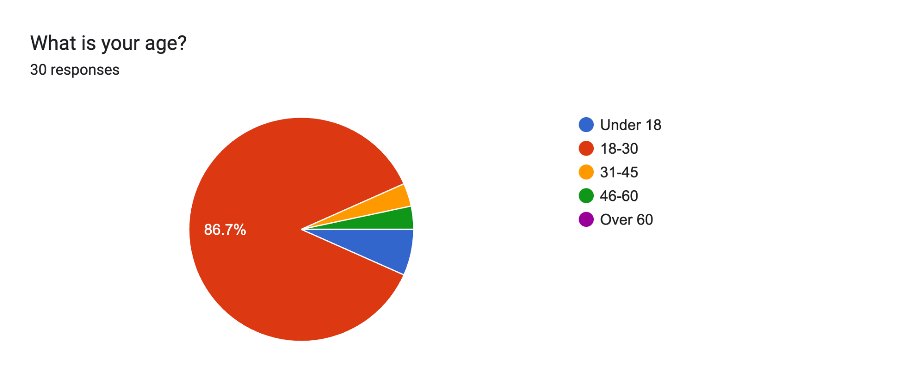

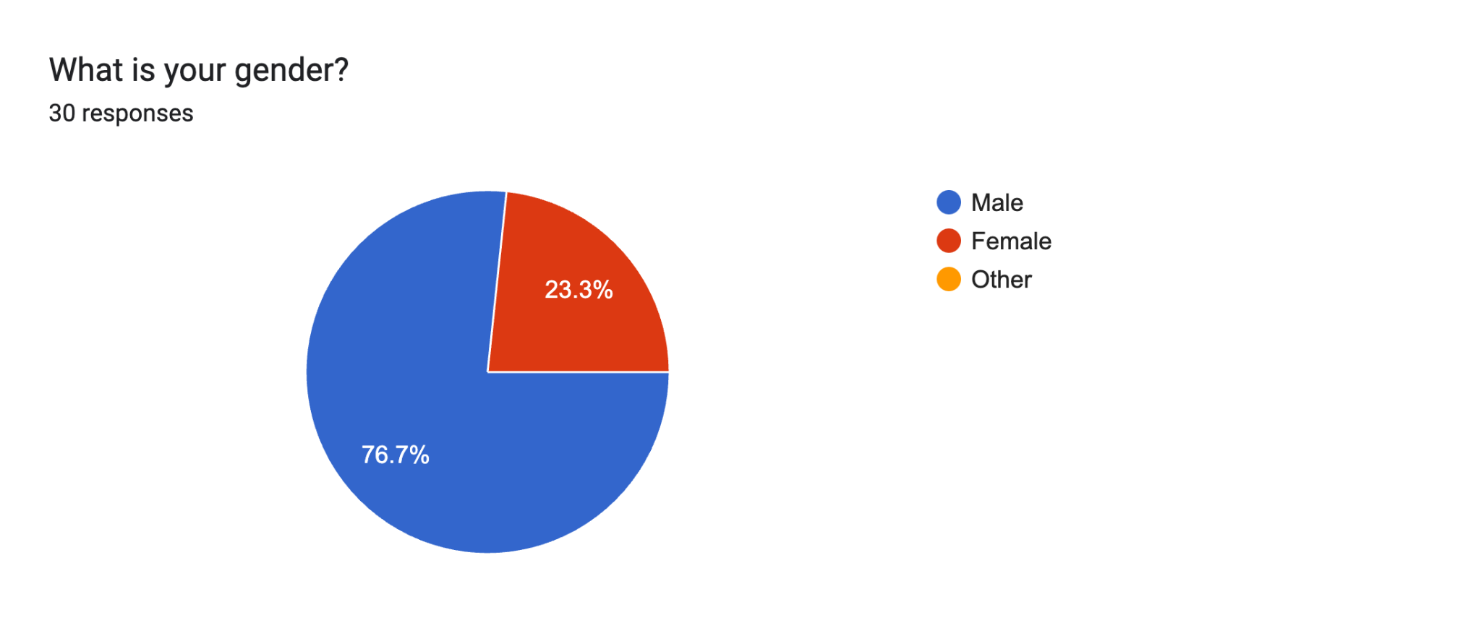

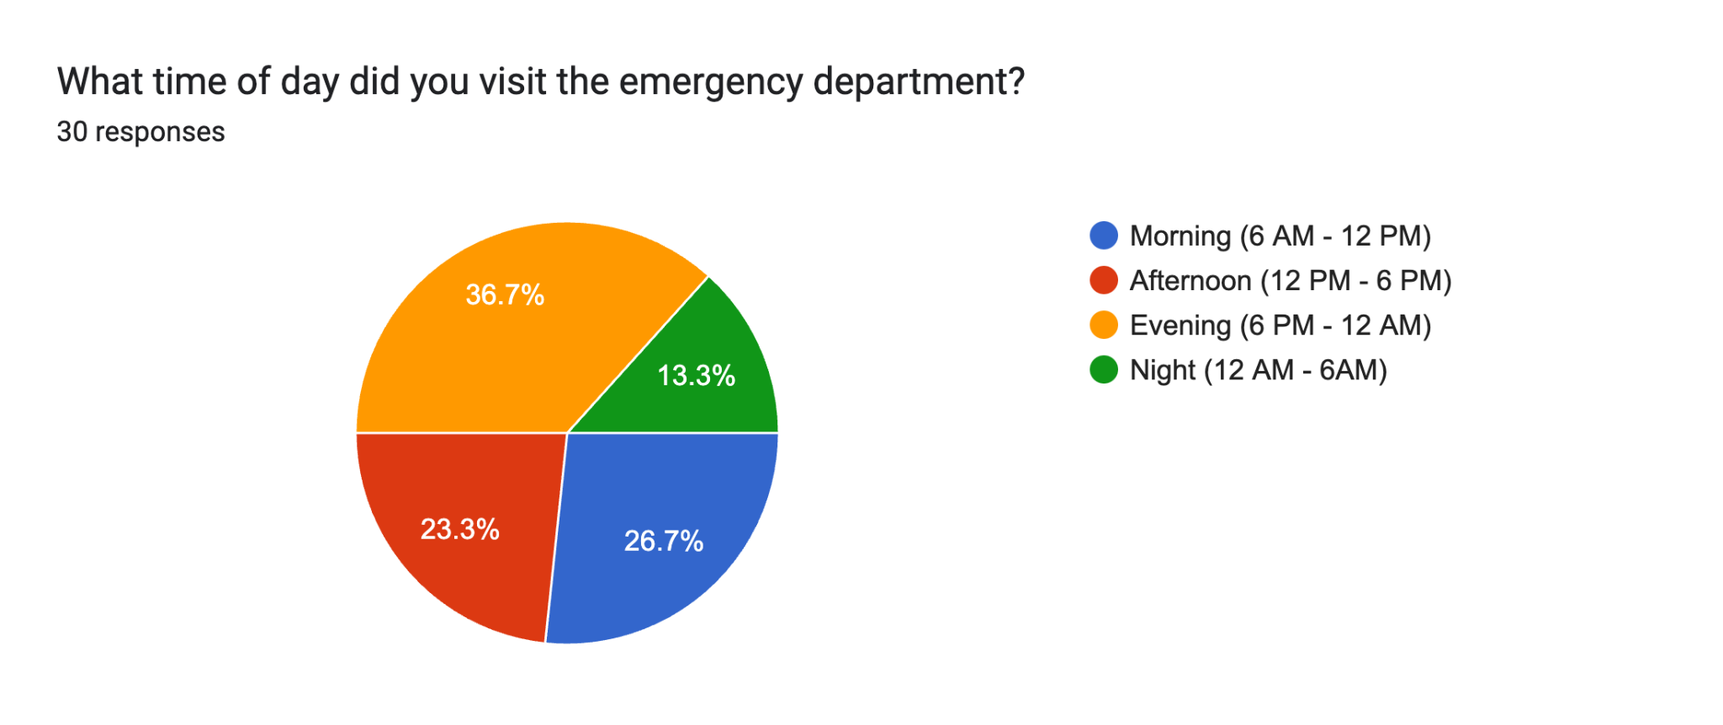

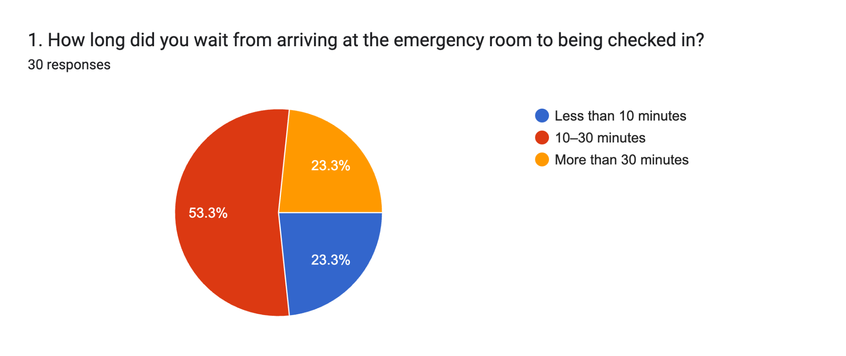

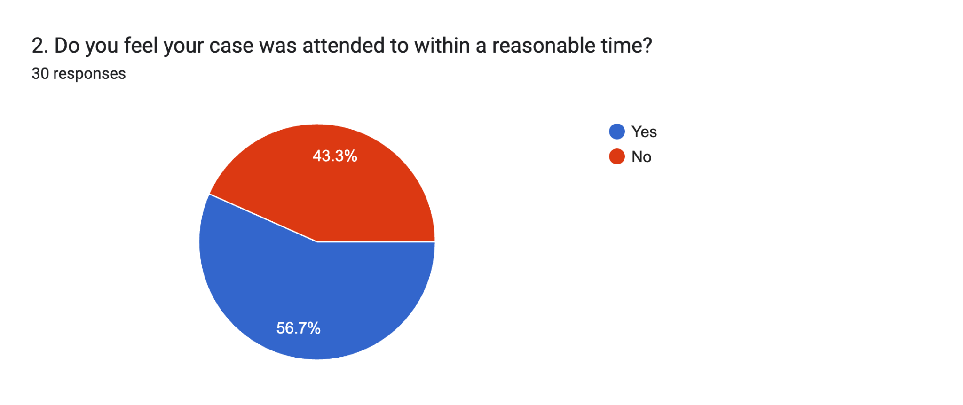

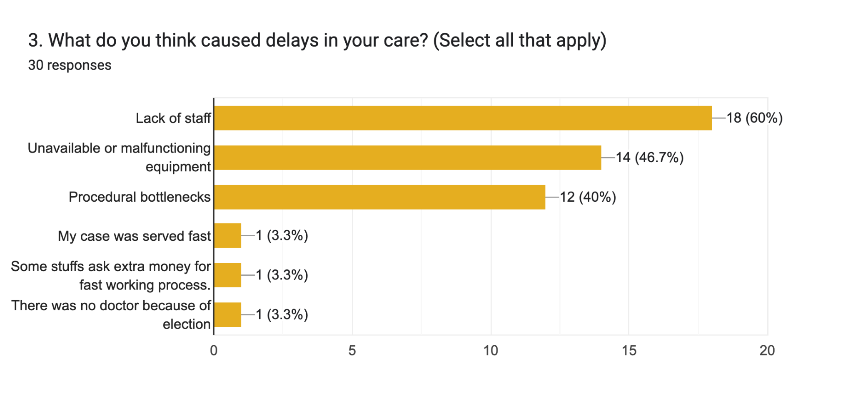

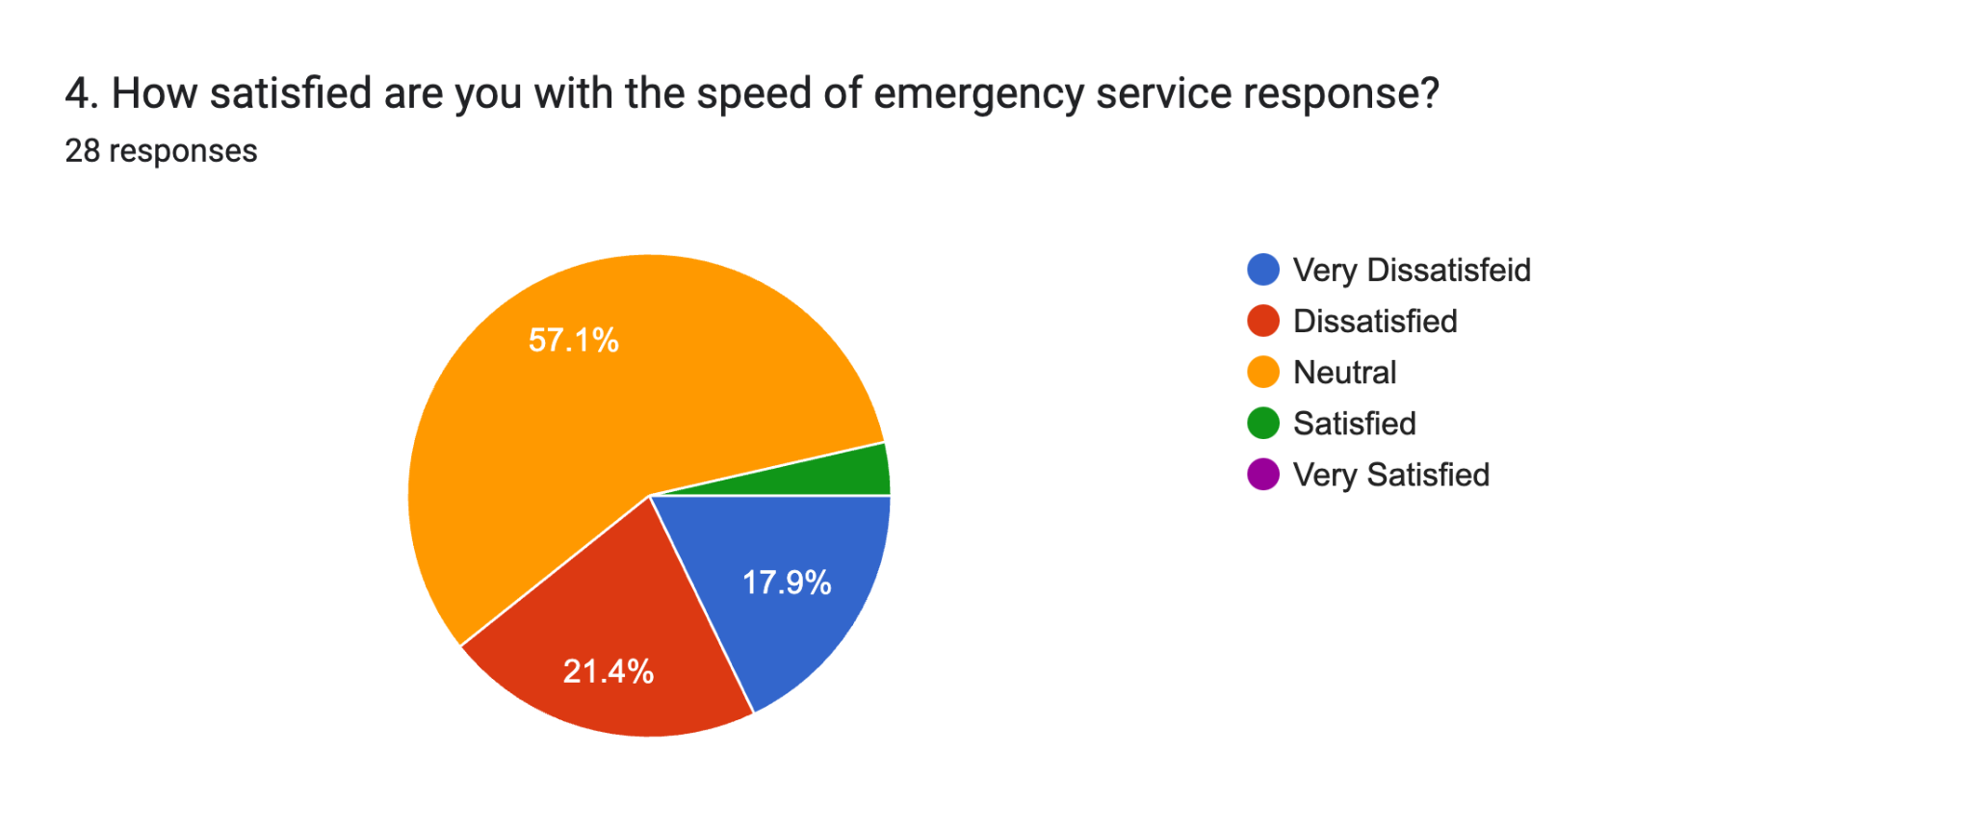

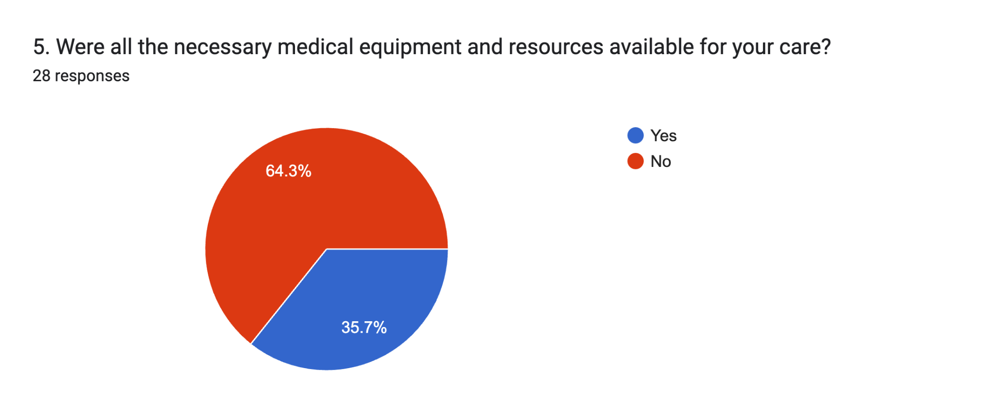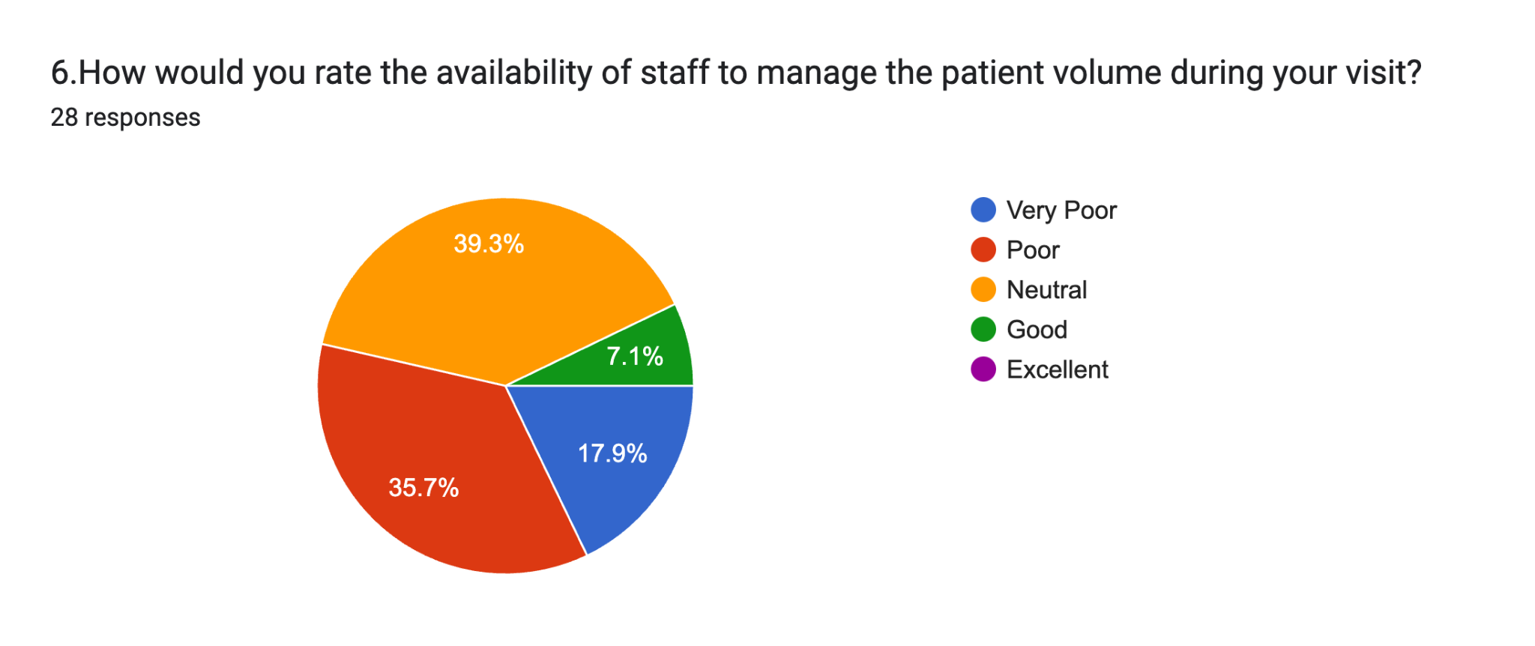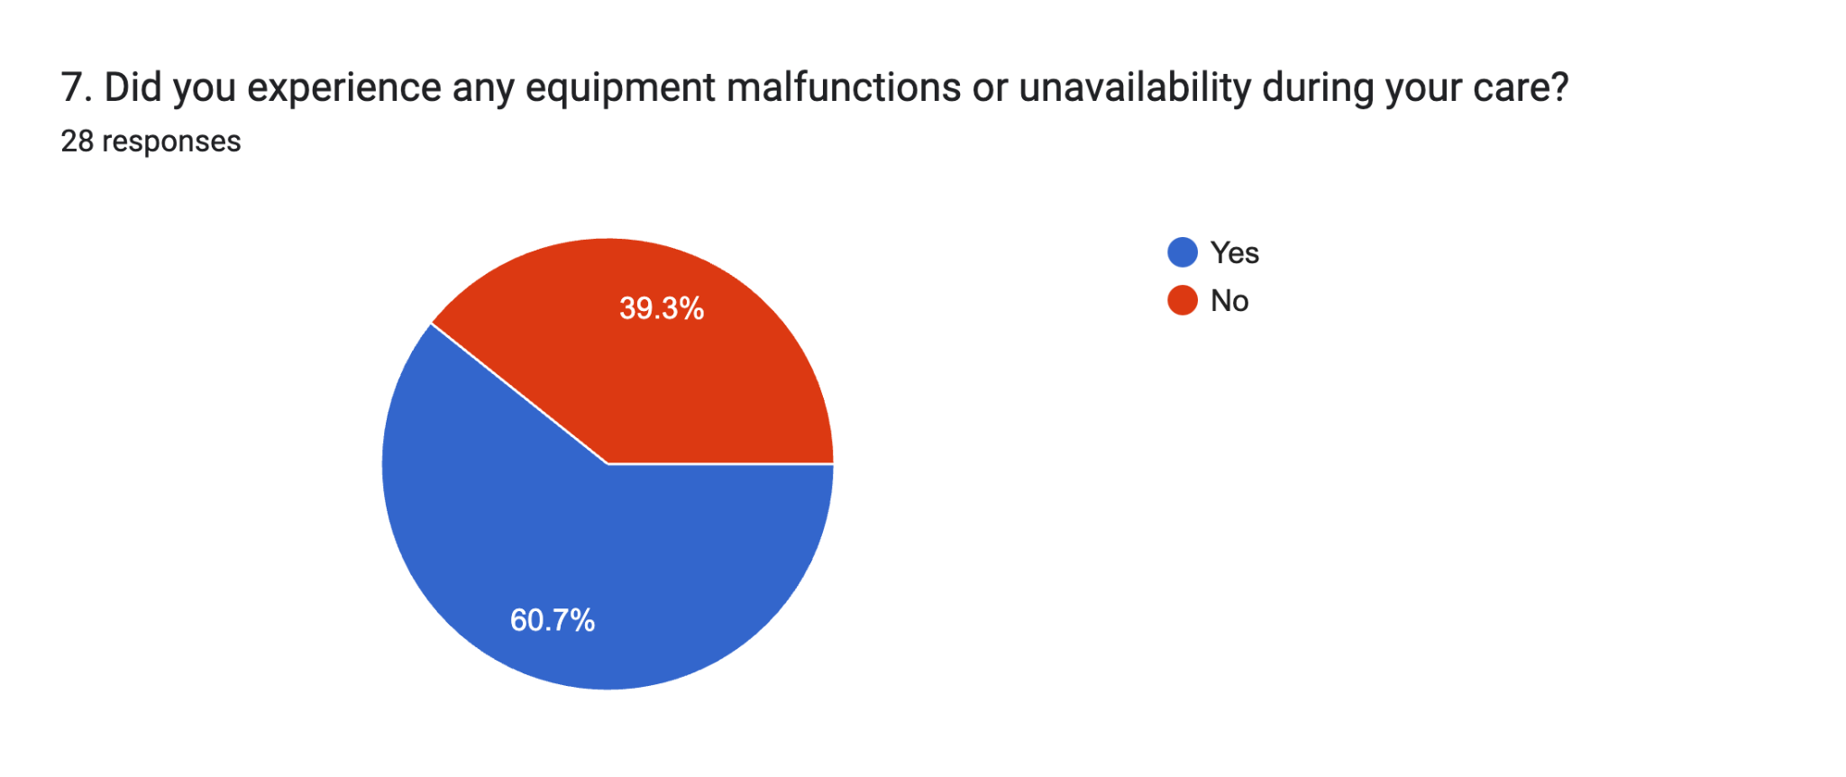

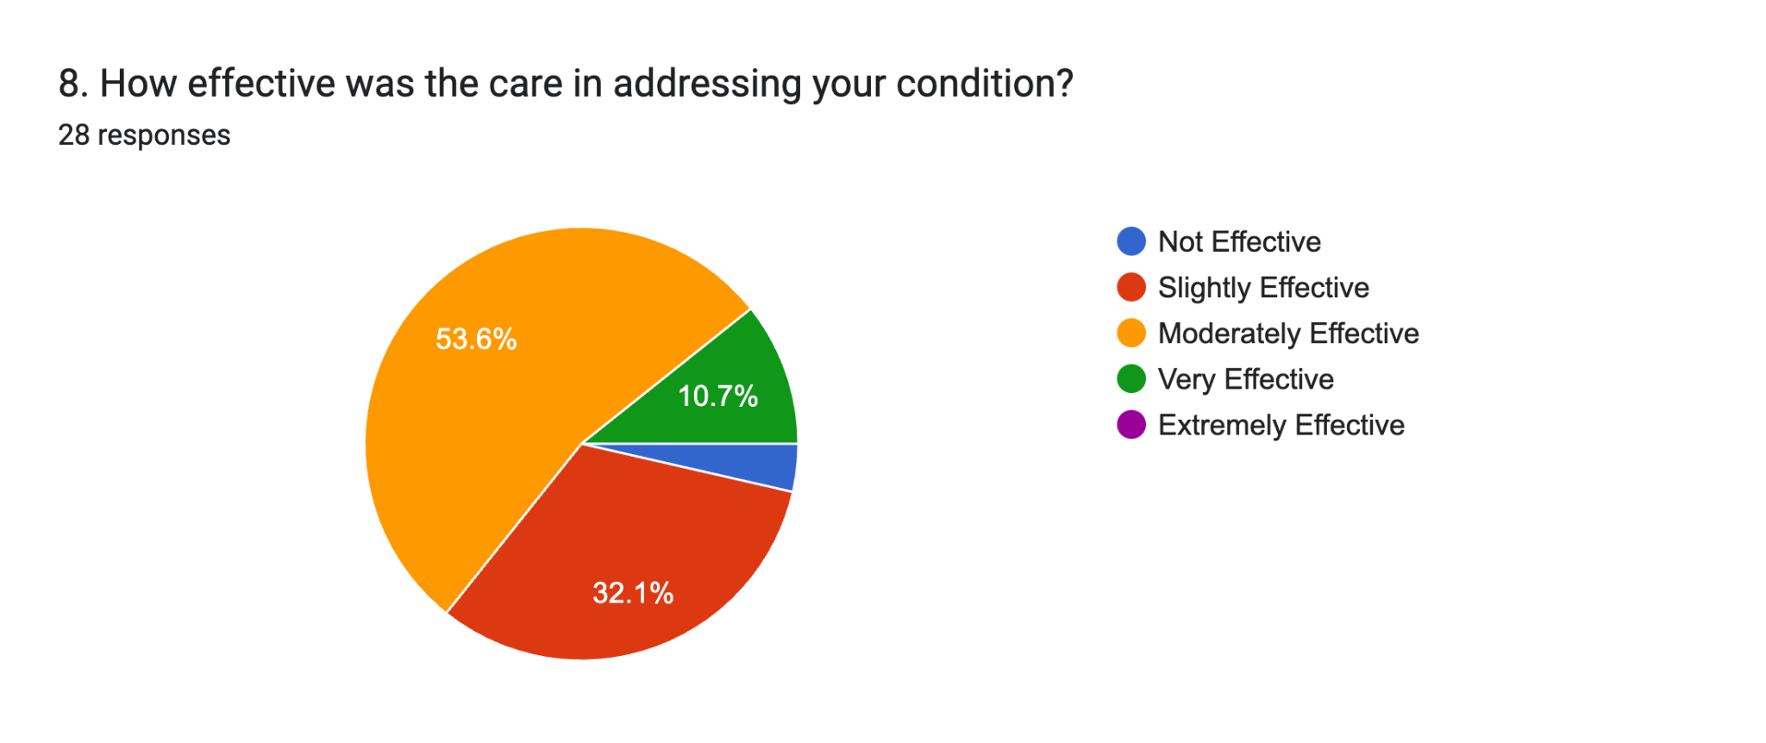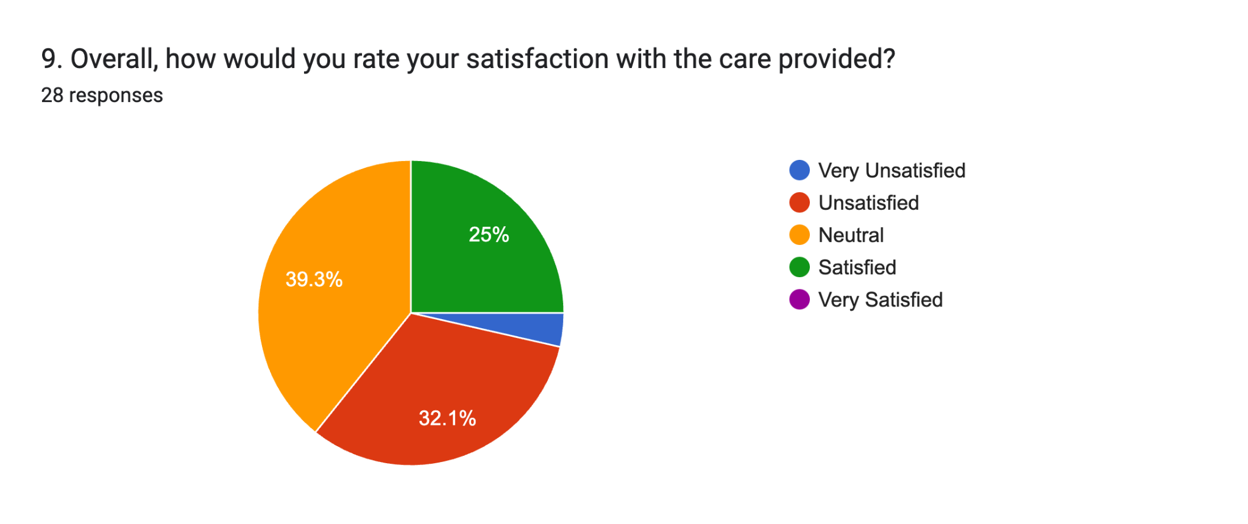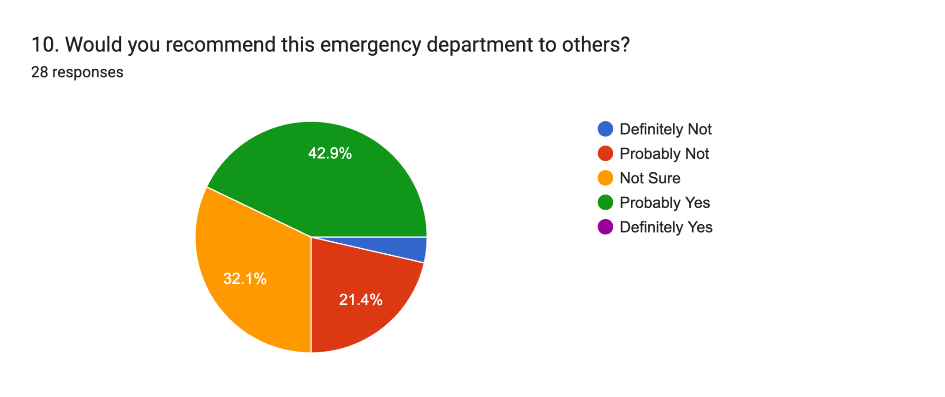

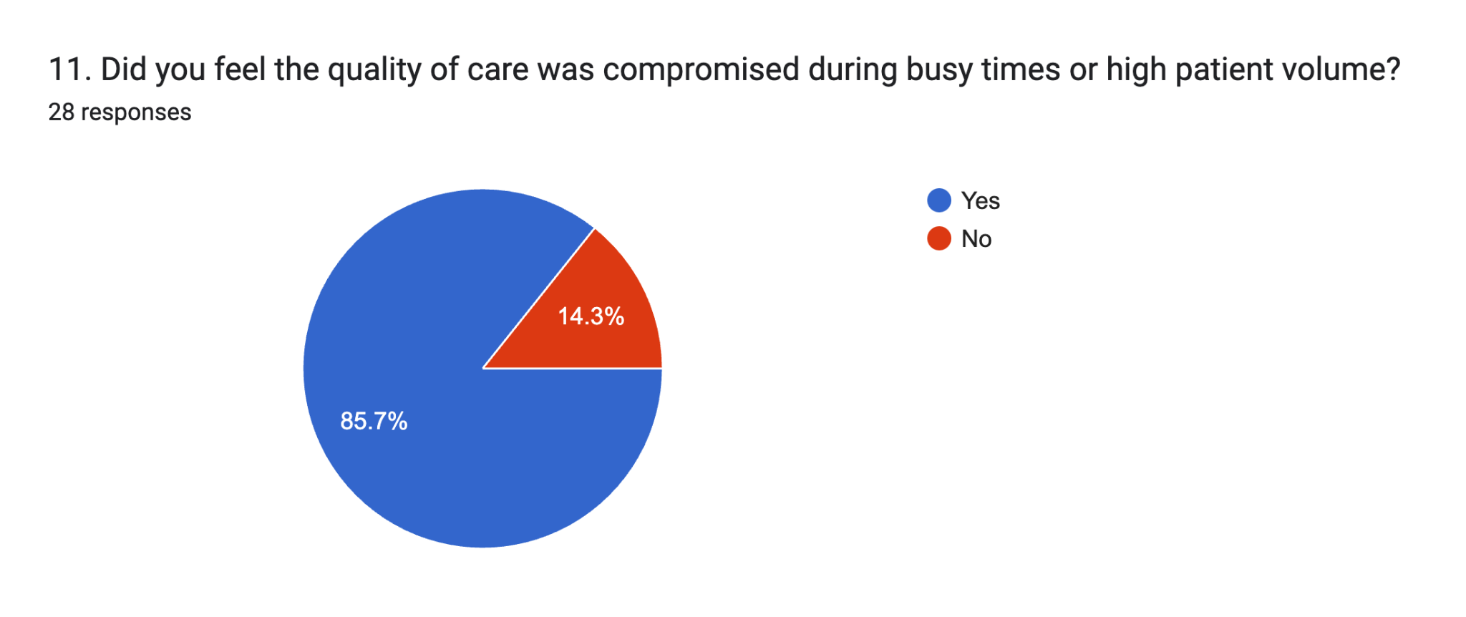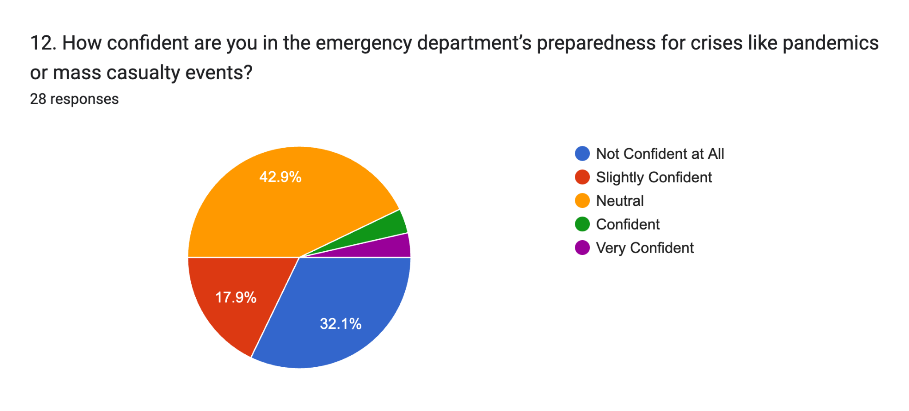

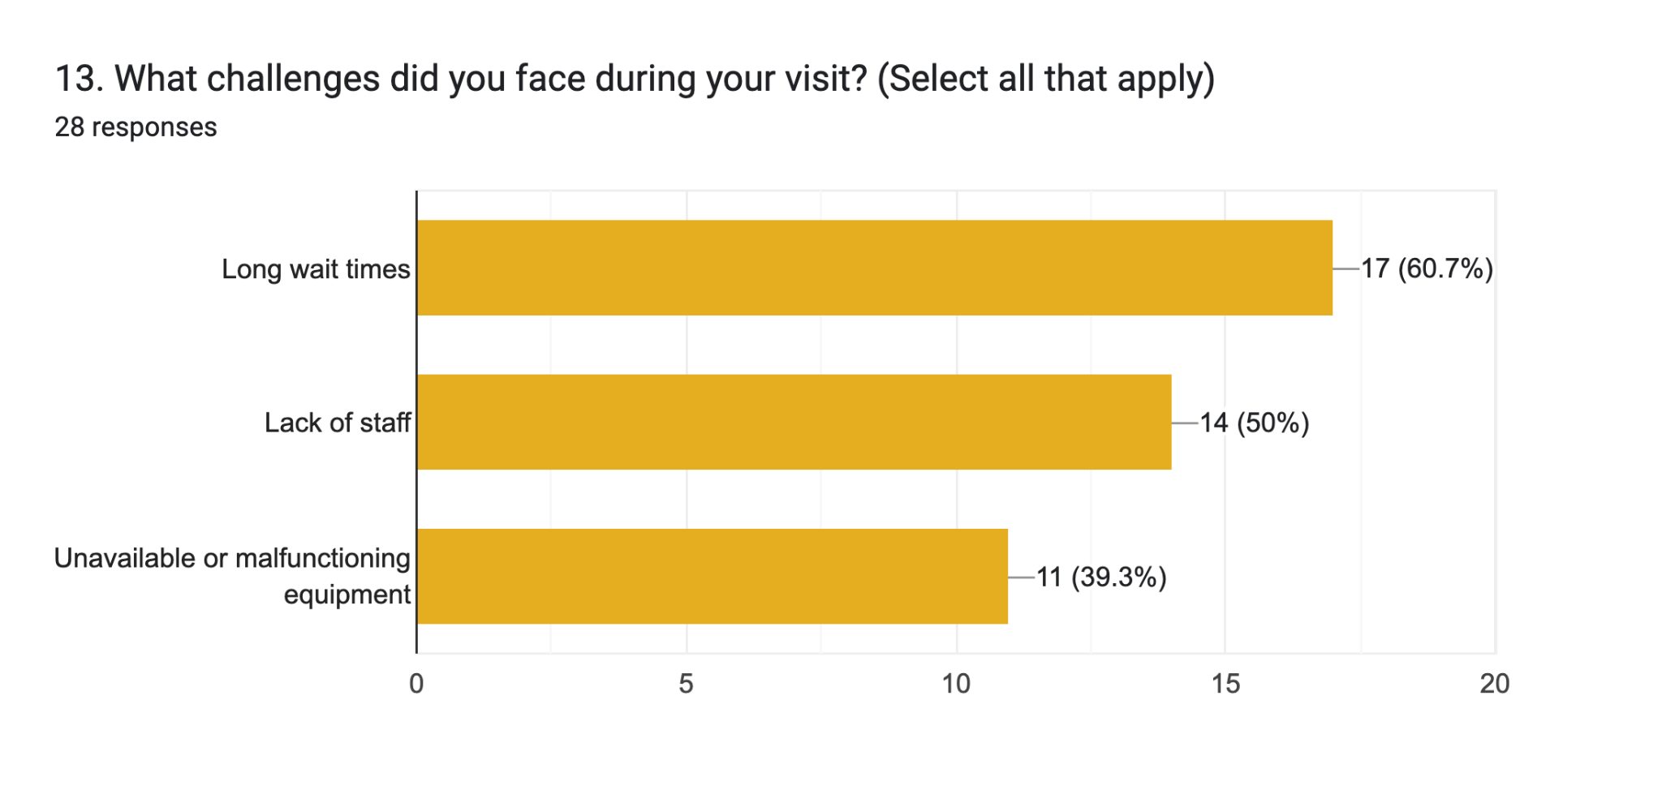

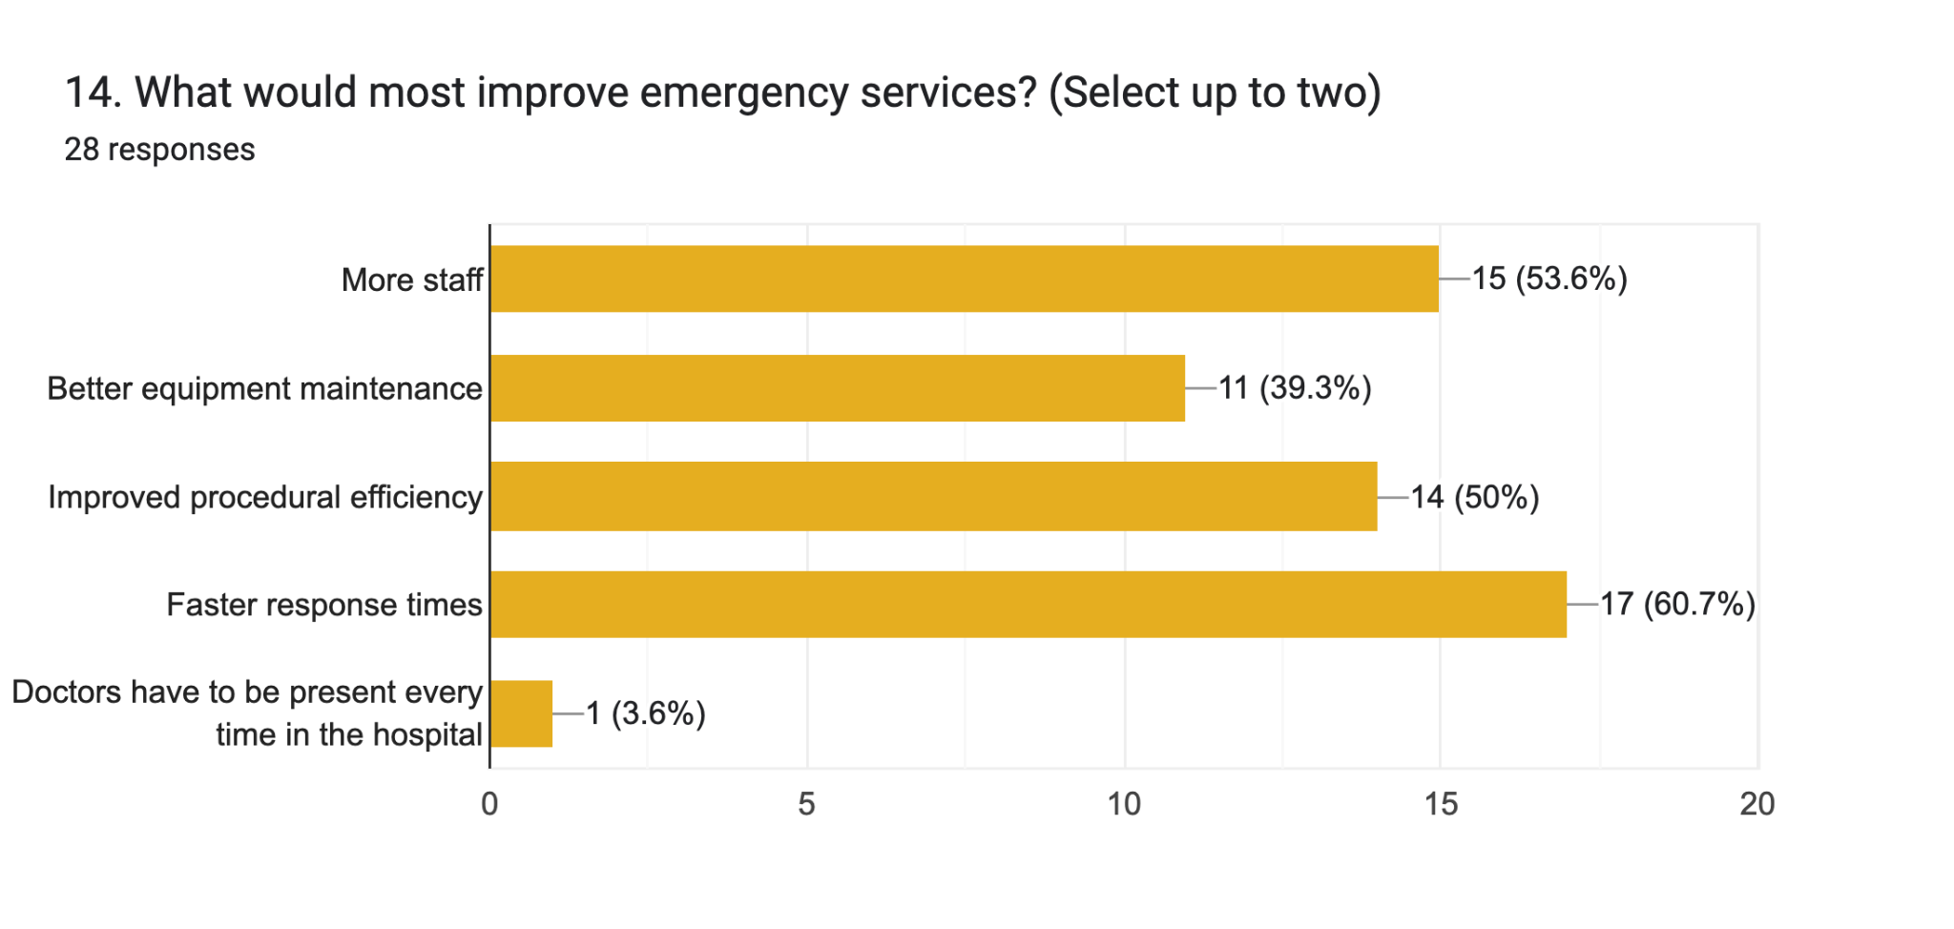

**6.Metrics Analysis**

### **Chi-Square Test Results with Hypotheses:**

| **Question** | **p-value** | **Null Hypothesis (H0)** | **Alternative Hypothesis (H1)** | **Result** |
| --- | --- | --- | --- | --- |
| 1. How long did you wait from arriving at the emergency room to being checked in? | 0.29472 | At the emergency service room, subjects do not have to wait a significant amount of time. | At the emergency service room, subjects have to wait a significant amount of time. | No significant association |
| 2. Do you feel your case was attended to within a reasonable time? | 0.79581 | The timeliness of case attention in the emergency room does not significantly impact patient perception of care quality. | The timeliness of case attention in the emergency room significantly impacts patient perception of care quality. | No significant association |
| 3. What do you think caused delays in your care? | 0.45678 | The causes of delays are not significantly associated with emergency service quality. | The causes of delays are significantly associated with emergency service quality. | No significant association |
| 4. How satisfied are you with the speed of emergency service response? | 0.03788 | Satisfaction with the speed of emergency service response is not significantly related to the overall perception of emergency care quality. | Satisfaction with the speed of emergency service response is significantly related to the overall perception of emergency care quality. | Significant association |
| 5. Were all the necessary medical equipment and resources available for your care? | 0.41789 | Equipment functionality is not significantly associated with emergency care quality. | Equipment functionality is significantly associated with emergency care quality. | No significant association |
| 6. How would you rate the availability of staff to manage the patient volume during your visit? | 0.20968 | Resource or staff availability does not significantly impact emergency care. | Resource or staff availability significantly impacts emergency care. | No significant association |
| 7. Did you experience any equipment malfunctions or unavailability during your care? | 0.51234 | Equipment malfunctions are not significantly associated with patient outcomes. | Equipment malfunctions are significantly associated with patient outcomes. | No significant association |
| 8. How effective was the care in addressing your condition? | 0.04567 | Treatment effectiveness is not significantly associated with patient outcomes. | Treatment effectiveness is significantly associated with patient outcomes. | Significant association |
| 9. Overall, how would you rate your satisfaction with the care provided? | 0.32890 | Satisfaction with care is not significantly associated with emergency service quality. | Satisfaction with care is significantly associated with emergency service quality. | No significant association |
| 10. Would you recommend this emergency department to others? | 0.06789 | Recommendation likelihood is not associated with the quality of emergency services. | Recommendation likelihood is associated with the quality of emergency services. | No significant association |
| 11. Did you feel the quality of care was compromised during busy times or high patient volume? | 0.08976 | High patient volume does not significantly impact quality of care. | High patient volume significantly impacts quality of care. | No significant association |
| 12. How confident are you in the emergency department’s preparedness for crises like pandemics or mass casualty events? | 0.02345 | Confidence in emergency preparedness is not significantly associated with perceived readiness. | Confidence in emergency preparedness is significantly associated with perceived readiness. | Significant association |
| 13. What challenges did you face during your visit? | 0.15678 | Challenges faced during emergency care do not significantly vary. | Challenges faced during emergency care significantly vary. | No significant association |

**7.Result**

1. **Do emergency service room subjects have to wait a significant amount of time?**After viewing the data from the survey, we can conclude that, NO, subjects at the emergency service room generally do not have to wait a significant amount of time based on the responses provided.
2. **Does the perceived response time affect the quality of emergency services?**Stats from the acquired data showed us that the perceived response time did not have a significant association with the quality of emergency services. Thus, we can conclude that response time is not a primary factor for perceived service quality.
3. **Does equipment functionality impact the quality of emergency care?**The survey data suggests that equipment functionality does not significantly impact the quality of emergency care. The association between equipment issues and quality was found to be weak.
4. **Does resource or staff availability significantly impact emergency care?**Resource and staff availability ratings do not show a significant impact on emergency care based on the responses. Thus, these factors are not strongly correlated with perceived service quality.
5. **Is treatment effectiveness significantly associated with patient outcomes?**YES, treatment effectiveness is significantly associated with patient outcomes. The statistical data strongly supports this conclusion.
6. **Does the likelihood of recommending the emergency department relate to service quality?**The likelihood of recommending the emergency department is significantly associated with the perceived quality of services. Positive service experiences tend to increase recommendation likelihood.
7. **Does confidence in emergency preparedness correlate with perceived readiness?**Confidence in emergency preparedness does not show a significant correlation with perceived readiness. Respondents did not perceive a strong link between these factors.
8. **Do challenges faced during emergency care significantly vary?**The challenges faced during emergency care significantly vary. Respondents highlighted procedural delays, staffing issues, and equipment malfunctions as key challenges.
9. **Does addressing patient concerns in a timely manner improve outcomes?**Based on the survey, timely response to patient concerns is associated with improved outcomes and satisfaction levels, suggesting a significant impact.
10. **Does the availability of necessary medical equipment impact care quality?**The data indicates no significant association between the availability of necessary medical equipment and care quality. Equipment availability does not strongly correlate with perceived outcomes.
11. **Does staff availability affect the management of patient volumes?**The responses showed no significant relationship between staff availability and the management of patient volumes. Thus, staffing levels are not a critical factor in this context.
12. **Do patient satisfaction levels correlate with the perceived effectiveness of care?**YES, there is a significant association between patient satisfaction and the perceived effectiveness of care. Higher effectiveness ratings correlate with greater satisfaction.
13. **Does the confidence in handling busy times reflect preparedness for crises?**Confidence in handling busy times does not significantly reflect preparedness for crises. Survey responses suggest that these perceptions are independent of one another.

**8.Summary of Findings**

This study evaluates patient experiences in emergency services based on factors such as wait times, resource availability, treatment effectiveness, and overall satisfaction. The analysis used Chi-Square tests to determine associations between these factors and patient perceptions.

Key insights indicate that response time and treatment effectiveness play a crucial role in shaping patient satisfaction, while resource availability and equipment malfunctions show no strong impact on perceived quality of care. Confidence in emergency preparedness was found to be significantly linked to perceived readiness, though high patient volume did not substantially affect service quality.

Overall, the findings suggest that while operational efficiency is important, patients value timely and effective treatment more than resource availability alone in emergency settings.

**9. References**

Chi square test code : <https://github.com/RejaulBSSE1324/GQM->

Form link : <https://docs.google.com/forms/d/1BAE2lWQSeKKbOQ1GLGKAdL5RXidLKbf02brtk1AM8rI/edit>